# Sub-1 GHz Transceiver

Has 433MHz antenna, and a CC1101 chip making Flipper a powerful transceiver capable of up to 50 meters range.

# 

# 125kHz RFID

## Low-frequency proximity cards

This type of card is widely used in old access control systems around the world. It's pretty dumb, stores only an N-byte ID and has no authentication mechanism, allowing it to be read, cloned and emulated by anyone. A 125 kHz antenna is located on the bottom of Flipper — it can read EM-4100 and HID Prox cards, save them to memory to emulate later.

You can also emulate cards by entering their IDs manually.

Moreover, Flipper owners can exchange card IDs remotely.

# iButton

## 1-Wire keys (Touch Memory)

Flipper Zero has a built-in 1-Wire connector to read iButton (aka DS1990A, Touch Memory or Dallas key) contact keys. This old technology is still widely used around the world. It uses the 1-Wire protocol that doesn't have any authentication. Flipper can easily read these keys, store IDs to the memory, write IDs to blank keys and emulate the key itself.

Flipper Zero has a unique contact pad design on the corner — its shape works as a reader and a probe to connect to iButton sockets at the same time. This mode is also handy for silently intercepting the 1-Wire data line.

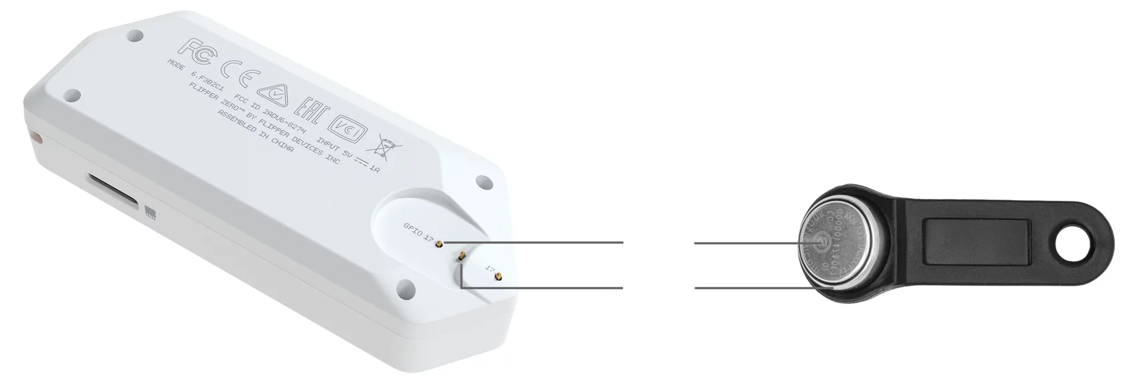

## What is iButton? [What Is an iButton Device? | Analog Devices](https://www.analog.com/en/technical-articles/what-is-an-ibutton-device.html)

An iButton device uses its stainless steel 'can' as an electronic communications interface. Each can has a data contact, called the 'lid', and a ground contact, called the 'base'. Each of these contacts is connected to the silicon chip inside. The lid is the top of the can; the base forms the sides and the bottom of the can and includes a flange to simplify attaching the iButton device to just about anything. The two contacts are separated by a polypropylene grommet.

The following are some of the application areas where iButton devices are used today and have been used consistently for decades.

Data Loggers

Asset Management

Electronic Asset Control

eCash

Guard Tour

# Infrared Transceiver

## Infrared Transmitter

The infrared transmitter can transmit signals to control electronics such as TVs, air conditioners, stereo systems and more.

Flipper has a built-in library of common TV vendor command sequences for power and volume control. This library is constantly updated by Flipper community users uploading new signals to Flipper’s IR Remote database.Infrared Transmitter

## Infrared learning feature

Flipper Zero also has an IR receiver that can receive signals and save them to the library, so you can store any of your existing remotes to transmit commands later, and upload to the public IR Remote database to share with other Flipper users.

# MicroSD Card

## External storage for apps and data

There is lots of heavy data Flipper has to store: remotes codes, signal databases, dictionaries, image assets, logs and more. All this data can be stored on an SD card, as well as user plugins.

The SD slot will have a push-push type connector, so the card will be reliably secured inside and won't stick out.

Flipper Zero will support any FAT32 formatted microSD card to store your assets so you’ll never have to worry the memory will run out. The card is not required for Flipper Zero to operate and is not included.

# Bluetooth

## Connect to apps

Flipper Zero has a built-in Bluetooth Low Energy module. As with other Flipper wireless features, we will be providing an open source library for adding Flipper support to community-made apps.

Full BLE support allows Flipper Zero to act as both a host and a peripheral device, allowing you to connect your Flipper to 3rd-party devices and a smartphone simultaneously.

Our mobile developers are designing official iOS and Android apps to let you unleash Flipper's potential with a larger screen and greater control.

# Connect with other Flipper zero devices

Flipper zero uses 433 MHz to communicate with other Flippers out there